Fall River Resource Conservation District
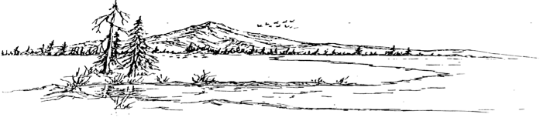
^{e-m}

BOARD MEETING AGENDA
Meeting Agenda - Tuesday, September 16th, 2025 at 6:00 PM
At the RCD Office Building in McArthur

Call Meeting to Order

Public Comment
Any person may address the board at this time about any subject within the jurisdiction of the Fall River Resource Conservation District; however, any matter that requires action will be referred to staff for a report and approve action at a subsequent meeting.

New Business
McArthur Swamp Pivot young farmer bidders’ preference
McArthur Swamp grazing lease 2026
Pheasant/Chuckar Hunt
McArthur Swamp Hunting Permits
Building Envelope for Trap Shooting Facility
Snake Pond Bids
Lake Property Blinds

Old Business

Procopio Letter – water rights

Consent Calendar
Minutes August 19th, 2025 Regular Meeting
Expenditures 08/20/2025 – 09/16/2025
Financial Reports including Profit and Loss, Balance Sheet, Transaction Reports, and Reconciled Bank Statements.

NRCS Report

Executive Directors Report
Scholarship thank you
Pop warner letter
BFP update

Range Managers Report
CDFW signage for Swamp
DU Well/Pipeline
McArthur Rd Pivot - Crop

Adjourn:
At any time during the regular session, the Board may adjourn to a closed session to consider litigation, personnel matters, or to discuss with legal counsel matters within the attorney/client privilege and it may be held in a closed session. Authority: Government Code Section 1126(a)(d)(g)

Next Regular Meeting Date – Tuesday, October 21st, 2025 – Beginning at 6:00 PM

