Fall River Resource Conservation District
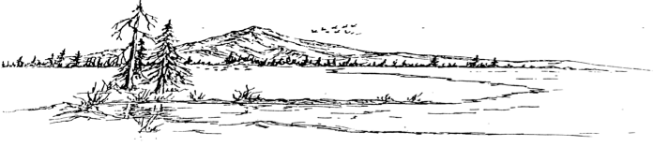
^{e-m}

BOARD MEETING AGENDA
Meeting Agenda - Tuesday, May 20th, 2025 at 6:00 PM
At the RCD Office Building in McArthur

Call Meeting to Order

Public Comment
Any person may address the board at this time about any subject within the jurisdiction of the Fall River Resource Conservation District; however, any matter that requires action will be referred to staff for a report and approve action at a subsequent meeting.

New Business
Office Real Estate Taxes
Fair Posters
New Signature Card
Organization Donations
Letter from McArthur Livestock
Scholarship Awards

Old Business
Range Manager Position
McArthur Swamp Chukar Hunt

Consent Calendar
Minutes April 8, 2025 Special Meeting
Minutes April 15, 2025 Regular Meeting
Minutes May 1, 2025 Special Meeting
Expenditures 04/16/2025 – 05/20/2025
Financial Reports including Profit and Loss, Balance Sheet, Transaction Reports, and Reconciled Bank Statements.

NRCS Report

Executive Directors Report
Financial Overview – Swamp and RCD
Grant Award
Trailer - Listed for Sale
Coyote Letter
Grant Status Report
BFP Report
JPA Update
Open House
Vector Solutions Certificates.
McArthur Swamp Checking Account

Range Managers Report
Gun Club Building Envelope
Partners Project Updates -FRPU
Grazing Seasons – Swamp and Fall River Lake
McArthur Swamp Pivot/ Wetland Delineation

Adjourn:
At any time during the regular session, the Board may adjourn to a closed session to consider litigation, personnel matters, or to discuss with legal counsel matters within the attorney/client privilege and it may be held in a closed session. Authority: Government Code Section 1126(a)(d)(g)

Closed Session:
Gov. Code section 54956.9(d)(2) – potential litigation

Next Regular Meeting Date – Tuesday, June 17th, 2025 – Beginning at 6:00 PM

