Fall River Resource Conservation District
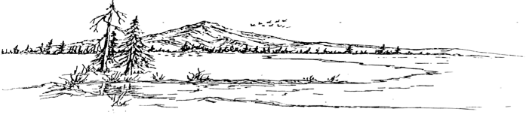
^{e-m}

BOARD MEETING AGENDA
Special Meeting Agenda - Tuesday, May 1st, 2025 at 6:00 PM
At the RCD Office Building in McArthur

Call Meeting to Order

Public Comment
Any person may address the board at this time about any subject within the jurisdiction of the Fall River Resource Conservation District; however, any matter that requires action will be referred to staff for a report and approve action at a subsequent meeting.

New Business
Range Manager Position

Next Regular Meeting Date – Tuesday, May 20th, 2025 – Beginning at 6:00 PM

