Fall River Resource Conservation District
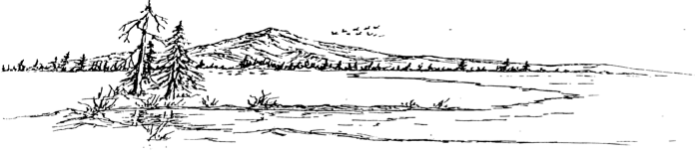
^{e-m}

BOARD MEETING AGENDA
Meeting Agenda - Tuesday, August 19th, 2025 at 6:00 PM
At the RCD Office Building in McArthur

Call Meeting to Order

Public Comment
Any person may address the board at this time about any subject within the jurisdiction of the Fall River Resource Conservation District; however, any matter that requires action will be referred to staff for a report and approve action at a subsequent meeting.

New Business
McArthur Swamp grazing lease 2026
Fall River Lake Property Ag Well
Chuckar Hunt
Welder/Torch/Pallet Forks purchase
Snake Pond Bids
Lake Property Blinds

Old Business
Investment account
Fair Poster
Procopio Letter – water rights

Consent Calendar
Minutes June 23rd, 2025 Regular Meeting
Expenditures 06/24/2025 – 07/22/2025
Financial Reports including Profit and Loss, Balance Sheet, Transaction Reports, and Reconciled Bank Statements.

NRCS Report

Executive Directors Report
Scholarship thank you
BFP Grants
Donation Request
Fall River CSD grant
SHARE Hunts
Property tax on office
Property tax income
Board member mileage reimbursement
Gun Club Building Envelope

Range Managers Report
Swamp Grazing
DU Well/Pipeline
McArthur Rd Pivot

Adjourn:
At any time during the regular session, the Board may adjourn to a closed session to consider litigation, personnel matters, or to discuss with legal counsel matters within the attorney/client privilege and it may be held in a closed session. Authority: Government Code Section 1126(a)(d)(g)

Next Regular Meeting Date – Tuesday, September 16th, 2025 – Beginning at 6:00 PM

